**SwE 482 Human-Computer Interaction**

**1nd Semester 2016/2017**

**Lab Assignment 5 Template**

**Assigned on 22 Nov 2017**

|  |  |
| --- | --- |
| Group Number | 4 |
| Section Number | 50136‎ |

|  |  |
| --- | --- |
| Assignment Number | 5 |
| Due Date | Sunday 17th Dec, before 1:00 pm. |
| Date of Submission | Sunday 17th Dec‎ |

|  |  |  |  |
| --- | --- | --- | --- |
| **Group Members** | | | |
| **#** | **Name** | **ID** | **Percentage of tasks she performs** |
| **1** | Sara Al meshari | 435202339 | 25% |
| **2** | Alzahra Alhowaish | 435201808 | 25% |
| **3** | Renad Almalki | 435201240 | 25% |
| **4** | Noura Alkhunifer | 435201094 | 25% |

**Table of Content:**

Part 1: Evaluation Plan 5

Part 2: Usability Tests 6

2.1 Participant Profiles 6

2.2 Timeline 7

2.3 Context of the Testing 7

2.4 Performance Measures and Feedback 7

2.5 Tasks 7

Part 3: Usability Results 8

3.1 Critical Problems 9

3.2 Major Problems 12

3.3 Minor Problems 14

3.4 Survey Result 16

Part 4: Recommendations 17

Part 5: Appendix 18

**Table of Figures:**

Figure 1:"Participants Data Analysis Graph" 6

Figure 2:"Tasks Success Distribution" 8

Figure 3:"Tasks Average time" 8

Figure 4:"Quantity Problem Screen " 9

Figure 5:"Before Changing Waters List" 10

Figure 6:"After Changing Waters List" 10

Figure 7:"After Changing Reservations List" 10

Figure 8:"User Searching About Added Reservations" 11

Figure 9:"Feedback Temporary Solution" 11

Figure 10:"suggestion Solution" 12

Figure 11:"Spinner for Date and Time" 12

Figure 12:"Before Adding Done in Main Menu" 13

Figure 13:"After Adding Done in Main Menu" 13

Figure 14:"Before Adding Edit Icon to List Element " 14

Figure 15:"After Adding Edit Icon to List Element " 14

Figure 16:"Before Adding Color and Borders to the Bill " 15

Figure 17:"After Adding Color and Borders to the Bill " 15

Figure 18:"Survey Result Graph" 16

**Table of Tables:**

Table 1:" Participants Profile" 6

Table 2:"Participants Data Analysis" 6

Table 3:"Participants Sessions Timeline" 7

Table 4:"Measurement Tools" 7

Table 5:"Tasks" 7

Table 6:" Recommendations and Changes" 17

# Part 1: Evaluation Plan

This document describes a test plan for conducting a usability test during the development of NARS restaurant management system. Participants will take part in the usability test at usability lap in the college of computer science at King Saud University. Using this application in Microsoft surface pro 3. The participant’s interaction with the application will be monitored by the facilitator in the same place. Note takers and data logger(s) will monitor the sessions, the screen used in the test sessions and the participant’s voice will be recorded. Participation will be asked to perform these tasks view reservation list, book a reservation, edit reservation, view waiters list, change table state, make order, view table bill, identify available and seated tables. We will take the participants feedback using prepared scale survey managed by Morae and making a short interview to know their full experience feedback. The participants will sign on consent form after greetings and get their profile information.

# Part 2: Usability Tests

## **2.1 Participant Profiles**

Table 1:" Participants Profile"

|  |  |  |  |  |
| --- | --- | --- | --- | --- |
| **Participant name** | **Age** | **Gender** | **Average knowledge of similar systems (1-5)** | **Use of handheld device or computers (1-5)** |
| 1. Jina | 35 | Female | 2 | 3 |
| 2. Alzahra | 30 | Female | 4 | 4 |
| 3. Ebtihaj | 19 | Female | 1 | 3 |
| 4. Nick | 20 | Female | 1 | 3 |

**a. Data Analysis**

Table 2:"Participants Data Analysis"

|  |  |  |  |
| --- | --- | --- | --- |
|  | **age** | **Average knowledge of similar systems** | **Use of handheld device or computers** |
| **mean** | 26 | 2 | 3.25 |
| **median** | 25 | 1.5 | 3 |
| **mode** | #N/A | 1 | 3 |
| **SD** | 7.78888 | 1.414213562 | 0.5 |

**b. Data Graph**

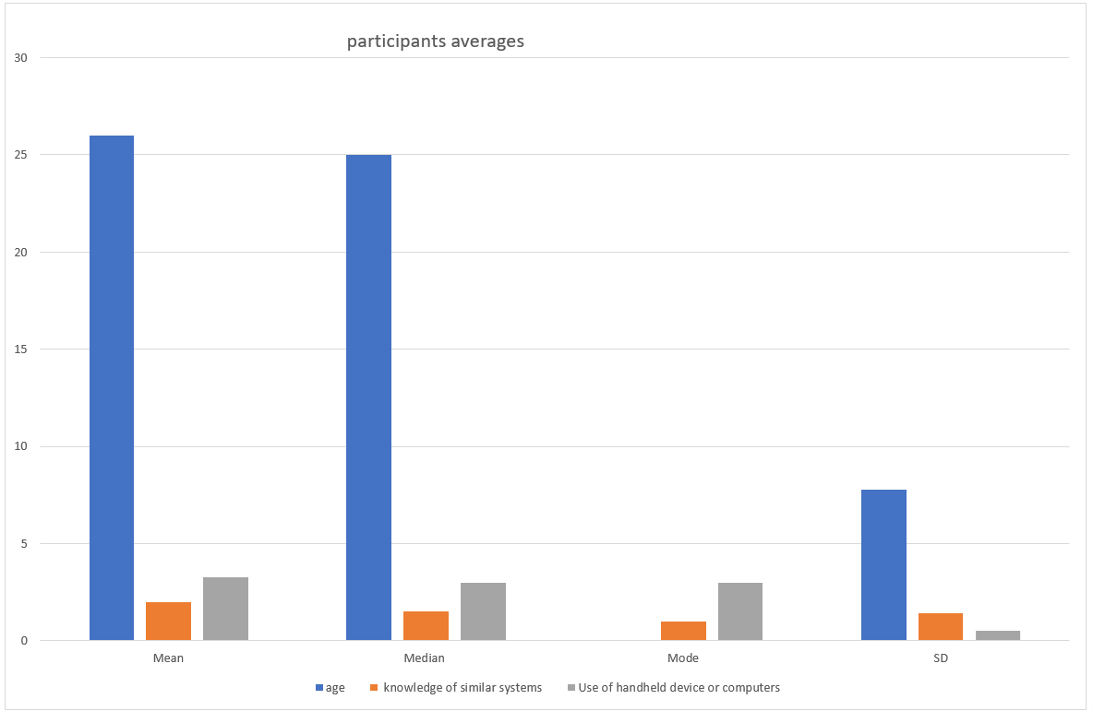

Figure 1:"Participants Data Analysis Graph"

## **2.2 Timeline**

User testing was conducted between 5/12/2017 and 7/12/2017.

Table 3:"Participants Sessions Timeline"

|  |  |  |  |  |  |
| --- | --- | --- | --- | --- | --- |
| **Participant name** | **Day** | **Date** | **Start session time** | **Finish session time** | **Duration of session** |
| 1. Jina | Wednesday | 6/12 | 9:25 | 9:41 | 16 min |
| 2. Alzahra | Wednesday | 6/12 | 9:51 | 10:01 | 10 min |
| 3. Ebtihaj | Thursday | 7/12 | 11:00 | 11:18 | 18 min |
| 4. Nick | Thursday | 7/12 | 10:34 | 10:39 | 5 min |

**\*Note:** All the participants take additional 10 minutes for greetings, interview and leaving talk in the end.

## **2.3 Context of the Testing**

Testing was conducted in the usability lab for all participants. The setting was restaurant and reception, were kept consistent at restaurant style.

## **2.4 Performance Measures and Feedback**

Table :"Measurement Tools"

|  |  |  |
| --- | --- | --- |
| **Metric** | **How was it measured?** | **How was the data created/captured?** |
| Effectiveness | Task success, Number of Errors, Complete score. | By using morae manager and recorder with microphone and screen recorder and analysis team. |
| Efficiency | Time on Task | Screen recording by using morae manager and recorder. |
| Satisfaction | User surveys | using laptop with mouse with morae surveys after recording. |
| System viewpoint | Interviews | By taking notes during the interview. |

## **2.5 Tasks**

Table :"Tasks"

|  |  |  |
| --- | --- | --- |
| Task # | Task | Objective of the task |
| 1 | book new reservation for Hala. | The objective of this task is to test the place of the reservation book tab and the clarity of adding functionality. |
| 2 | Edit booked reservation time for Sara. | The objective of this task is to test the edit functionality place and clarity. |
| 3 | View tables assigned to waiter Jack. | The objective of this task is to test the place of view waiters tab. |
| 4 | Change table 2 state from available to seated. | The objective of this task is to test the functionality of change table state from available to seated and the under stability of colors changes. |
| 5 | Take table 2 order. | The objective of this task is to test the clarity of take order and the restaurant menu view. |
| 6 | Show the bill for table 2. | The objective of this task is to test the clarity of view the bill. |
| 7 | Change table 2 state from seated to dirty. | The objective of this task is to test the functionality of change table state from seated to dirty and the under stability of colors changes. |
| 8 | Change table 2 state from dirty to available. | The objective of this task is to test the functionality of change table state from dirty to available and the under stability of colors changes. |

**\*Note:** You can find in the appendix D the scenario that we used to achieve the tasks.

# Part 3: Usability Results

After we done with all our participants we make a project in morae manager and added all records. We watch all record, logs task and highlights main problems that the participants stocked on. In addition, we wrote notes about anything we noticed through watching recording sessions again.

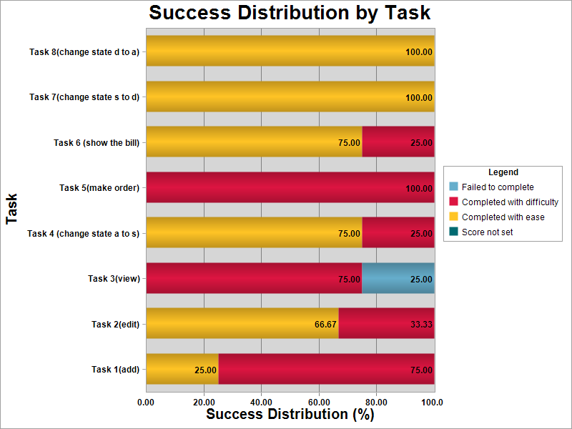

Figure :"Tasks Success Distribution"

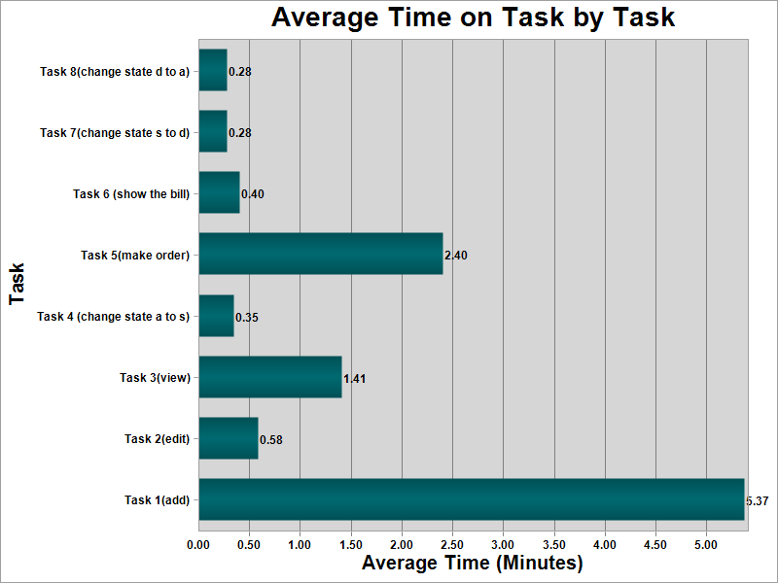

Figure :"Tasks Average time"

## **3.1 Critical Problems**

**3.1.1 Quantity functional problem in make order task**

The make order task was very difficult to complete as shown in figure 2, task 5. After analysis four participants record we discover none of them finished the task without sticking to increase quantity when they want to add order, for example, Greek salad as shown in the figure below and video 1 in appendix E. The quantity doesn't change, that’s because we didn’t implement the functionality in our prototype. All participants ask for help and we told them that the functionality not completed yet, but kindly complete the task with imagining that the quantities are increasing. There are more reasons make this task difficult but this one is the most important because all participants did the same.

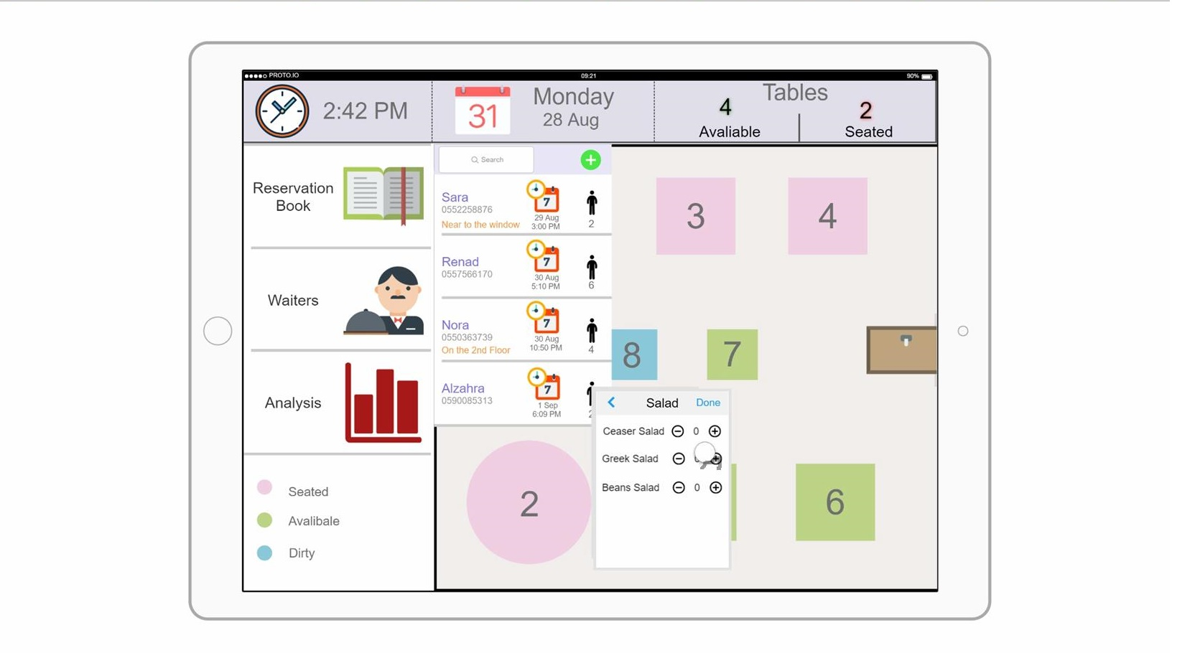

Figure :"Quantity Problem Screen "

**3.1.2 Close lists in view waiters task**

In view waiters list task to view jack assigned tables, the task was very difficult to done and one of the participants didn’t do it at all as shown in figure 2, task 3. Also, it takes a long time as shown in figure 3, task 3 while it needs less than 30 seconds. That’s because when they have done from add reservation then clicking on waiters tab the list doesn’t appear because the list opens under reservation list, then they try to close reservation list by clicking on tables area and other areas as shown in video 2 in appendix E, since the reservation list doesn't have close button, some participants click on reservation again to close it others received a hint. We must add a close button to reservation list and in waiters list as well to reduce the time and making functioning smoothly to the receptionist. The change was done as figures below.

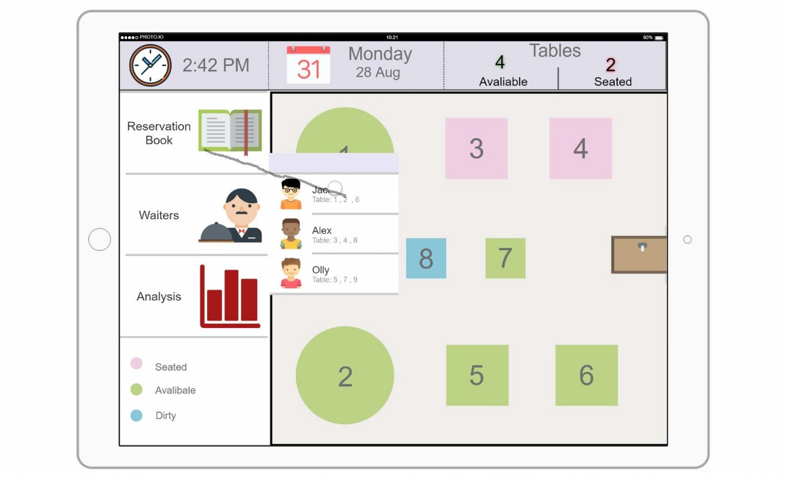

Figure :"Before Changing Waters List"

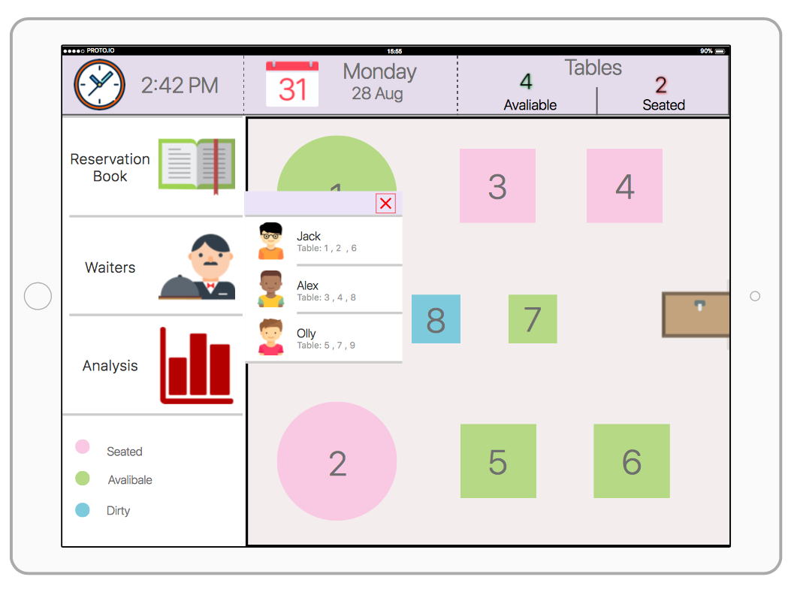

Figure :"After Changing Waters List"

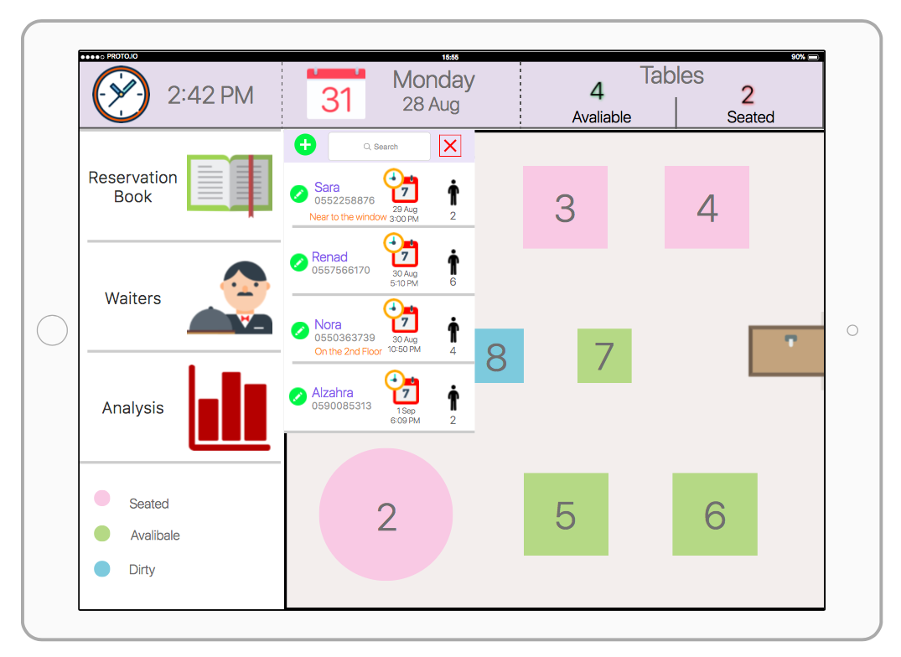

Figure :"After Changing Reservations List"

**3.1.3 Check booked reservation in book new reservation task**

The book new reservation task was very difficult to complete as shown in figure 2, task 1. Because after adding new reservation all participants checked customer name by searching as shown in figure 8 and video 4,5 in appendix E, and they didn't find it that makes them not sure if the reservation added or not even when the system gave right icon feedback below. The reason behind that is we didn’t implement complete adding functionality because that needs real programing language and we only did the interface by simple elements. So, we probably will put the right icon sign animation after disappearing the form. These changes shown in figure 9.

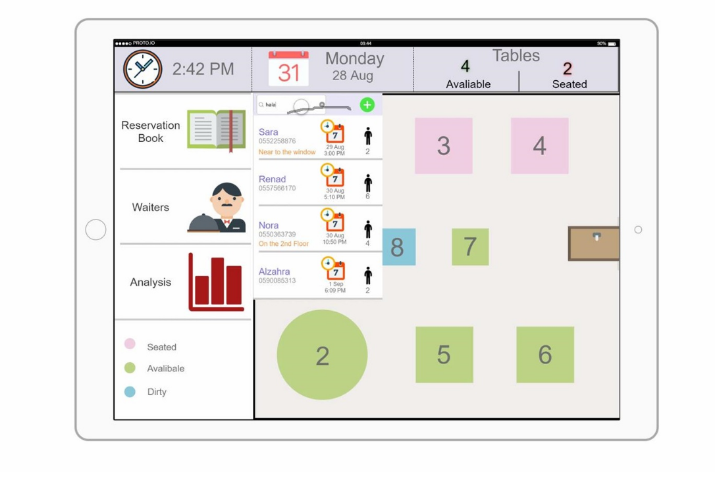

Figure :"User Searching About Added Reservations"

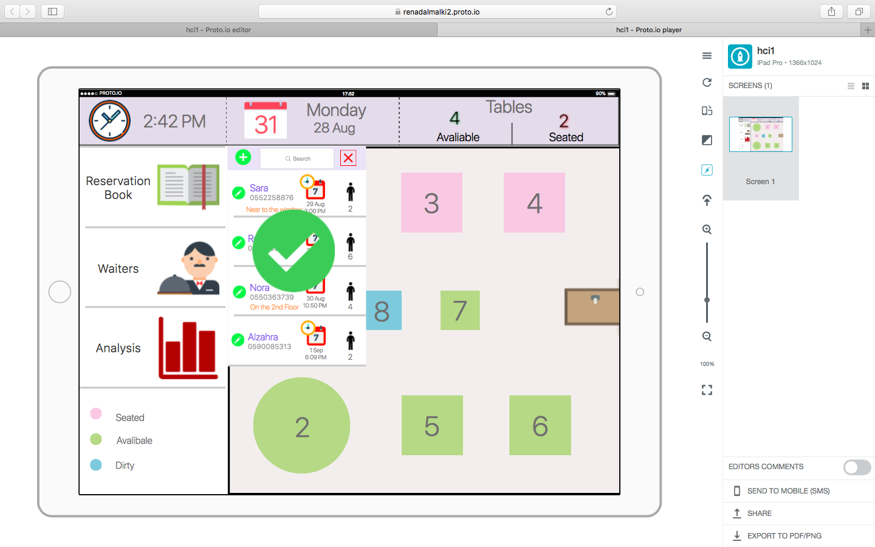

Figure :"Feedback Temporary Solution"

## **3.2 Major Problems**

**3.2.1 Date and time spinner in book new reservation task**

The book new reservation task was very difficult to complete as shown in figure 2, task 1. In addition to 3.1.3 problem, there is date and time spinner some participants didn’t know how to change date and time as shown in figure 11 below, some asked: “am I supposed to scroll?” maybe it is not clear for them since the scroll not very popular in phones platforms except IOS. Also, the time and date weren’t atomic, where the minutes and he hours are in same element and the day with the month in the same element, we noticed that is not efficient. So, if we change it we would make it as a table as shown in figure 10.

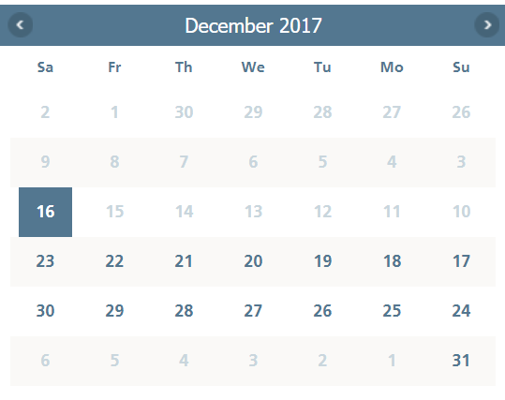

Figure :"suggestion Solution"

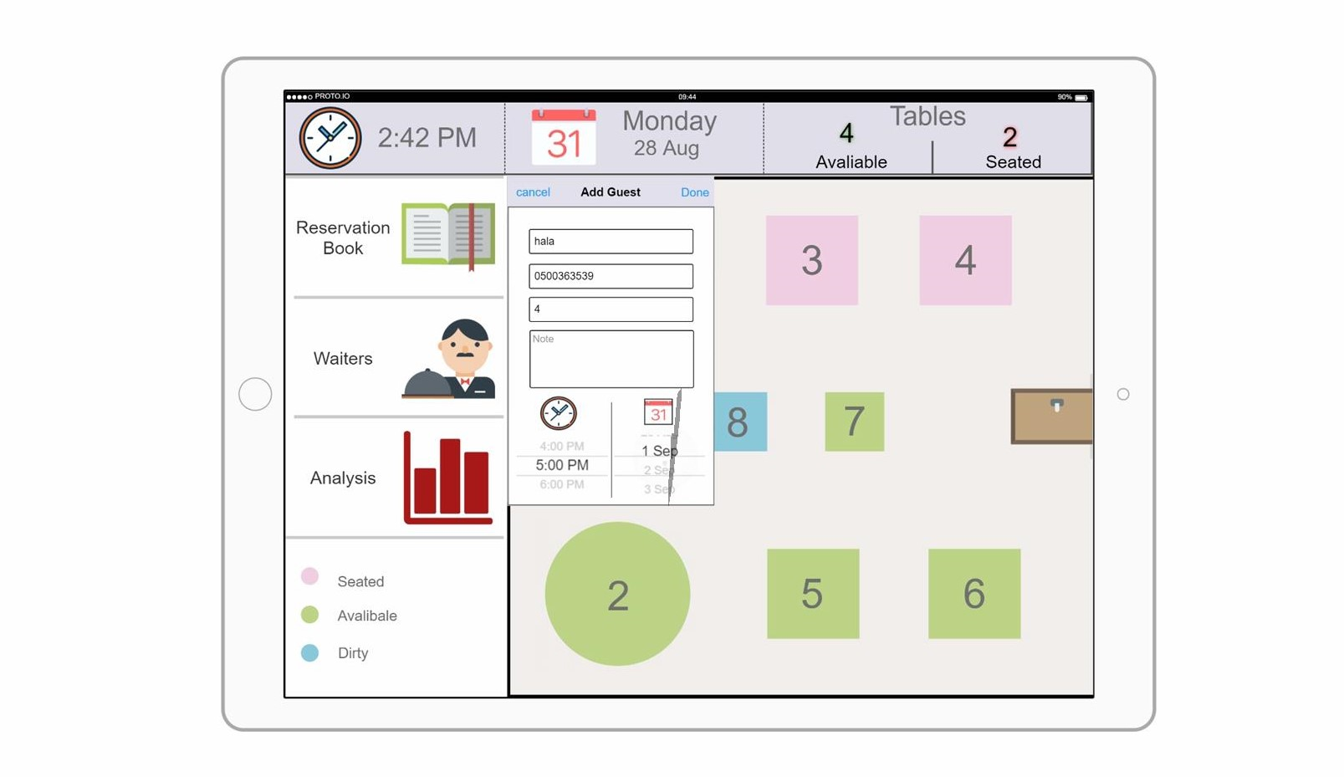

Figure :"Spinner for Date and Time"

**3.2.2 Done feedback in make order task**

The make order task was very difficult to complete as shown in figure 2, task 5. In addition to problem 3.1.1 there is the done feedback when the waiter has done from making the order there is no feedback that the order has recorded or send to the kitchen. We change that by adding animation when waiter clicks on done in the main menu the changes shown in figure 13 below.

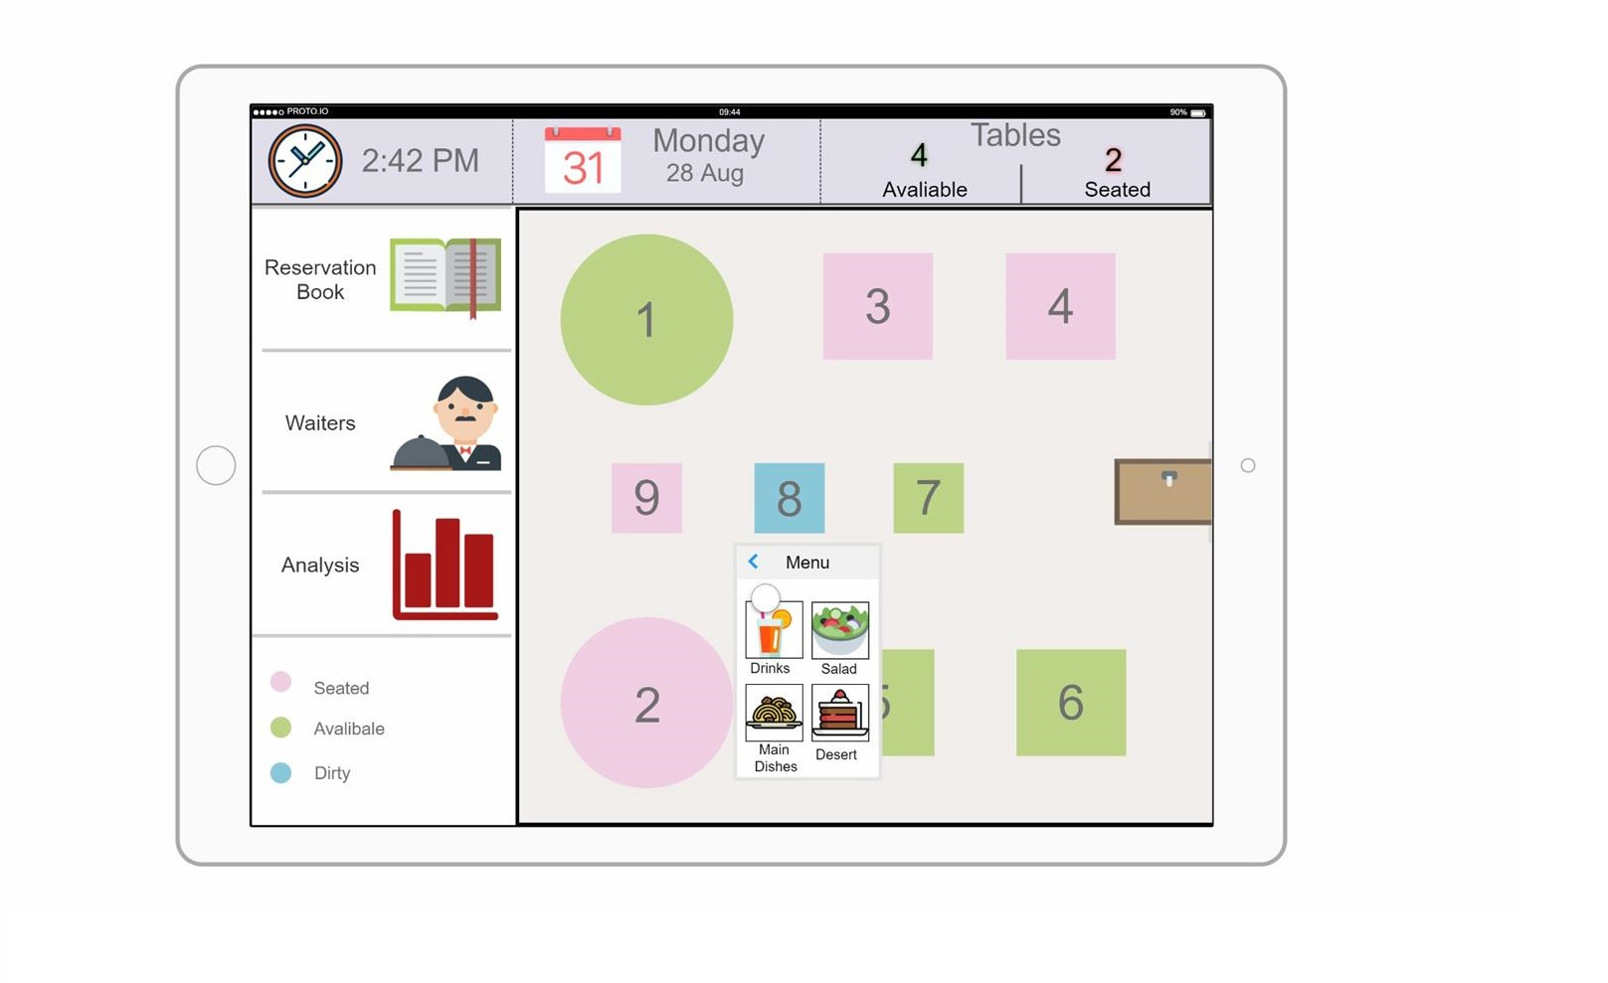

Figure :"Before Adding Done in Main Menu"

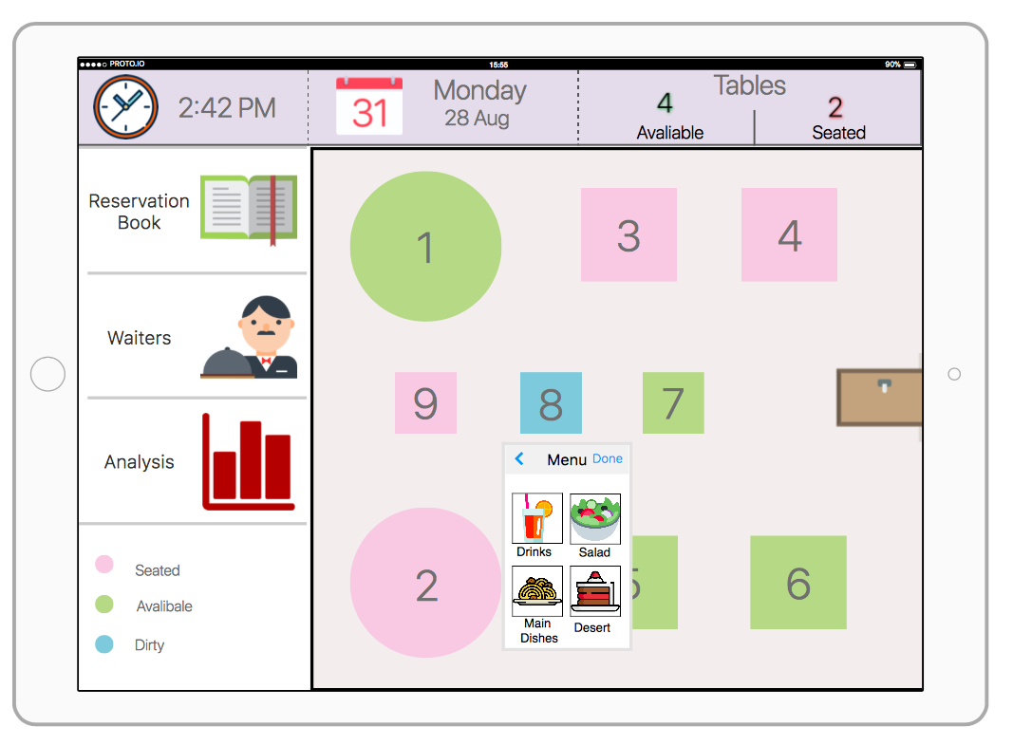

Figure :"After Adding Done in Main Menu"

## **3.3 Minor Problems**

**3.3.1 Access booked reservation to edit in edit booking task**

As shown in figure 2, task 2. Some participants didn’t understand how to access added reservation to edit it so, we decided to add an icon reflex editing function to the left of the list element to make it clearer to the user. We change it as shown in figure 15 below.

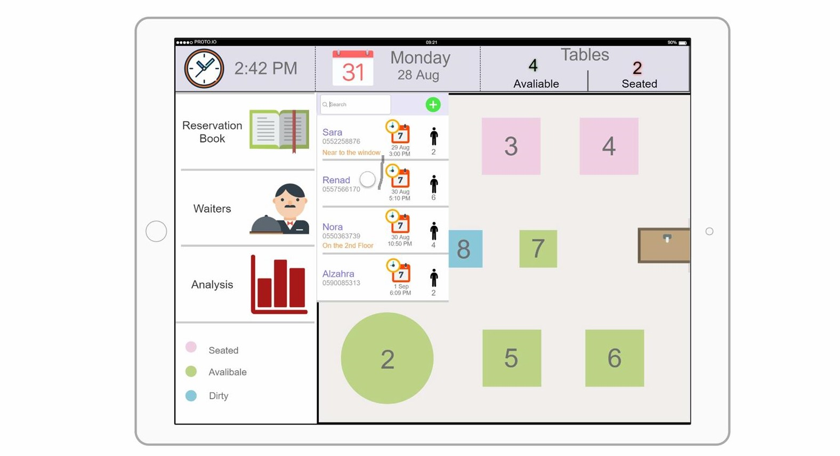

Figure :"Before Adding Edit Icon to List Element "



Figure :"After Adding Edit Icon to List Element "

3.3.2 Close bill in show bill task

The show bill task was difficult to complete for some participants as shown in figure 2, task 6. In showing the bill, some participants close the order, bill menu before showing the bill and they return to state menu then seated option as shown in figure 16 and video 3 in appendix E. This makes the process slow, if we want to change that it will be with if statement in the real code. Also, the close bill wasn't clear for all participants since, it has no borders and its color like bill content colors. For that, we change it as shown below in figure 17.

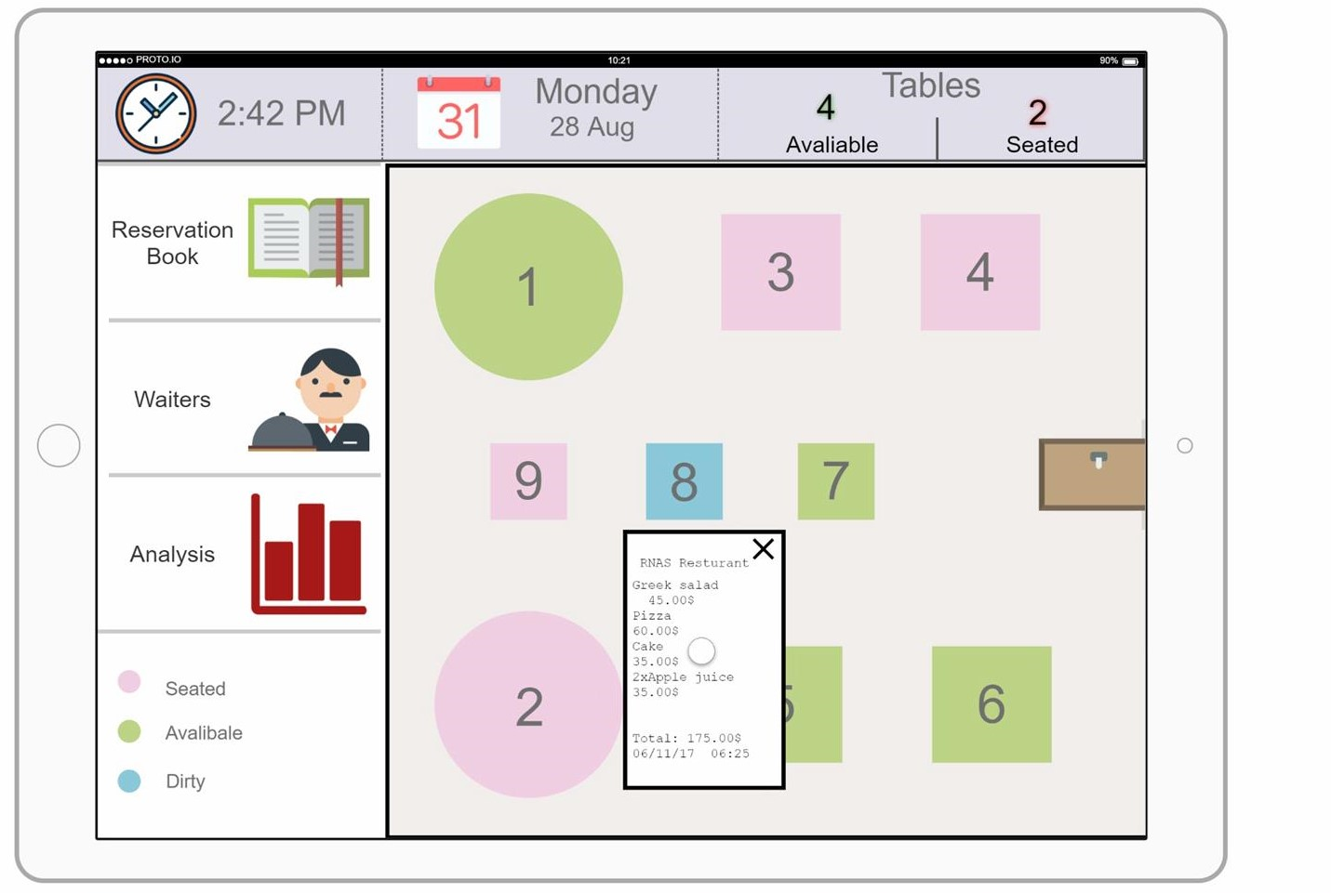

Figure :"Before Adding Color and Borders to the Bill "

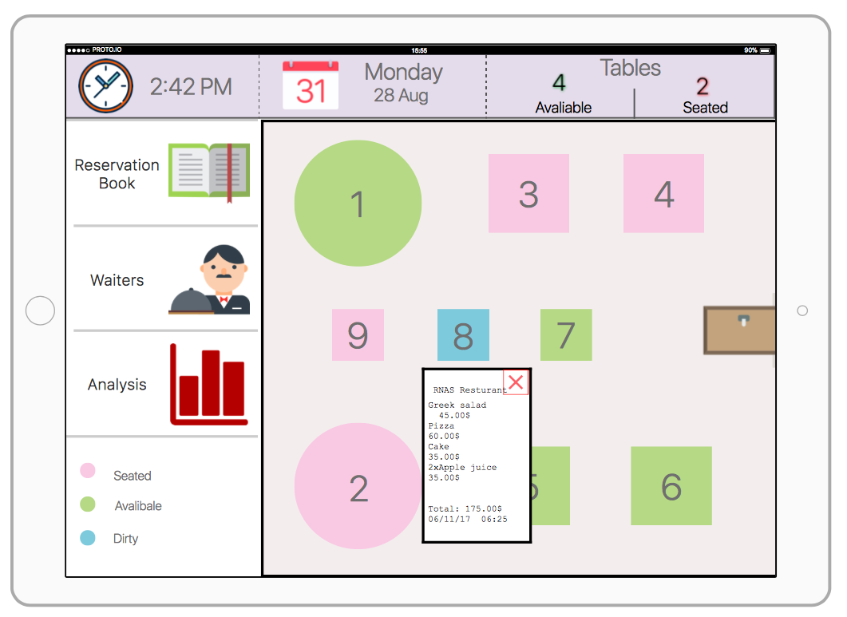

Figure :"After Adding Color and Borders to the Bill "

## **3.4 Survey Result**

The survey questions are in appendix B, the results analysis is as shown in figure 18 below.

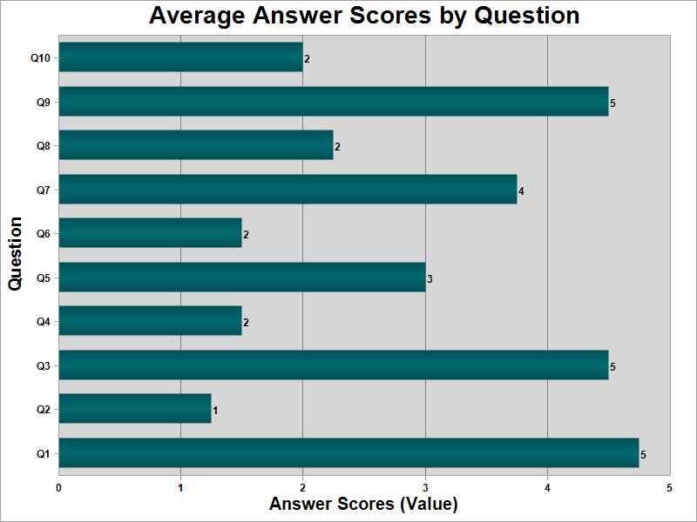

Figure :"Survey Result Graph"

It reflects that:

1. Most of the users want to use it again and again.
2. The system was not complex for most users.
3. The system was easy to use for most users.
4. Most of the users didn't need help to use the system.
5. Most of the users didn't agree that all functions are integrated well
6. Most of the users didn’t think that the system has too much inconsistency.
7. Most of the users imagine that most restaurants staff will learn to use the system very quickly.
8. Most of the users didn’t find the system cumbersome to use.
9. Most of the users were confident using the system.
10. Most of the users didn’t need any instruction to understand the system and work on it.

# Part 4: Recommendations

Table :" Recommendations and Changes"

|  |  |  |  |
| --- | --- | --- | --- |
| **Usability Issue** | **Recommendation** | **Severity** | **reason** |
| Close lists in view waiters task | Add “X” button in the waiter tab. | **Critical** | Some participants didn't know how to close waiters tab to view waters list tab |
| Close lists in reservation tab | Add “X” button in the reservation tab. | **Critical** | Some participants try to close reservation list by clicking on tables area and other areas. |
| Close bill in show bill task | Change “X” color and add border in order tab. | **Major** | Some participants didn't know how to close bill tab. |
| Done feedback in make order task | Add feedback when click done order | **Major** | Some participants return when she clicks done order |
| Access booked reservation to edit in edit booking task | Add an icon reflex editing function to the left of the list element. | **Minor** | Some participants didn’t understand how to access added reservation to edit it |
| Check booked reservation in book new reservation task | Add feedback after disappearing the form when click done order. | **Critical** | all participants checked customer name by searching and they didn't find it that makes them not sure if the reservation added or not |

# Part 5: Appendix

## **A. Consent Form**

Consent Form

The following form is designed to take your information and your signature that you agree to participate in using our NARS restaurant management system at the usability lab in Computer and information sciences college to help us in our study.

Name:............................................

Age:..............

Gender: □ Female □ Male

Average knowledge of similar systems (1-5)

1 2 3 4 5

Use of handheld device or computers (1-5)

1 2 3 4 5

Signature:................................................

Thank You!

## **B. Questionnaires Script**

## 

## **C. Facilitator Script**

* Before the session starts we set the tablet and prepare the usability lab for participants.

Hi, thank you for participating in our study.

Before we begin, can you please fill this form first?

You probably already have an idea of why we asked you here, but let me give you an overview of our system. It’s a restaurant system to book a reservation, manage the tables and make an order.

We want you to know that we are testing our system, not you. So we can see whether it works as intended.

I’m going to give you a small scenario that includes some tasks that you will suppose that you are as a receptionist then as a waiter and try to complete these tasks.

But I just want you to know that the system not completed yet and any changes you made won’t appear in our system. For example, if you book a reservation, the reservation won’t appear in the reservation list.

As you use the site, I’m going to ask you as much as possible to try to think out loud: to say what you’re looking at, what you’re trying to do, and what you’re thinking. This will be a big help to us.

Also, please If you have any questions as we go along, just ask us.

We may not be able to answer them right away, since we’re interested in how people do when they don’t have someone to help them. But if you still have any questions when we’re done we’ll try to answer them then.

With your permission, we’re going to record what happens on the screen and our conversation. The recording will only be used to help us figure out how to improve our system, and it won’t be seen by anyone except the people working on this project.

You can start now

* One of us will be in the room while the participant is using the system to help her if needed and the other team members will be in the other room.
* When participant done all task,

Ok great, Can you fill the survey, please?

-When she done filling the survey.

So, now, we are done.

All that's left is just a few questions. Ok?

How you find the system? Isn't easy or hard to use?

What do you think of the colors and the icons?

Is there anything that we can make to improve the system?

* Write on a piece of paper their feedback.

Many thanks for all you work today. You’ve been really helpful. I hope you enjoyed it!

* Give treat as shown in appendix F

Thank You again!

## **D. Task scenario**

Part 1:

Suppose you are a receptionist in NARS restaurant and you had call from customer Hala that she was to book a reservation.

Name: Hala

Phone No.0500363539

party No. 4

In 12/2/2018

At 5:30 PM

Then you will have had another call from customer Sara that she wants to change her booking party No. from 2 to 5

Part 2:

Suppose you are the waiter Jack now and you want to know what tables assigned to you.

Then new customers seated on table 2 you must change its state from available to seated.

After that you will take their order which is (Greek salad, Pizza ,2 apple juice, cake),

After that you will show the bill with the total.

Customer left the table you should change its state from seated to dirty,

Lastly, you will change table state after cleaning from dirty to available.

## **E. Videos link**

Dropbox link <https://www.dropbox.com/sh/9xfvneov55nwmf2/AACFvtN5nqgrFzDYxZGuzAIja?dl=0>

## **F. Treats**

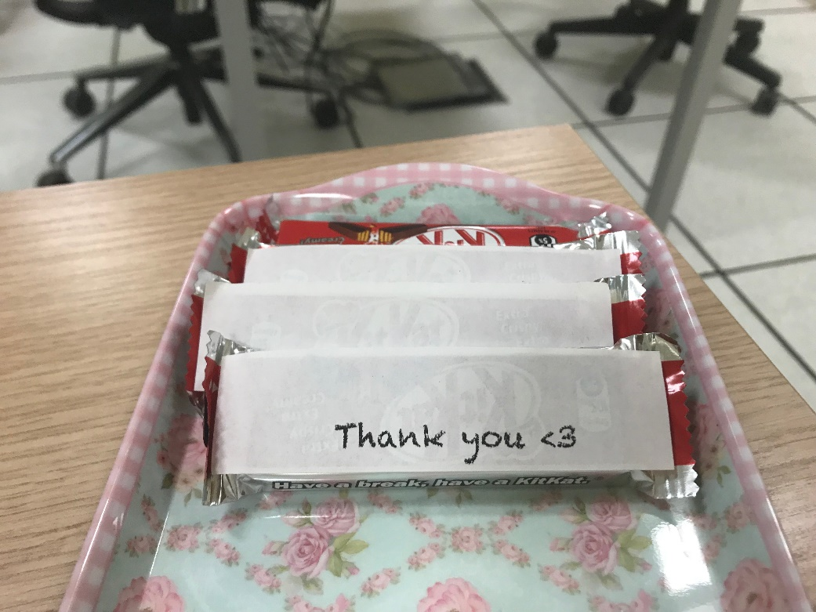

## **G. Consent Form signed by participants**

Participant 1:

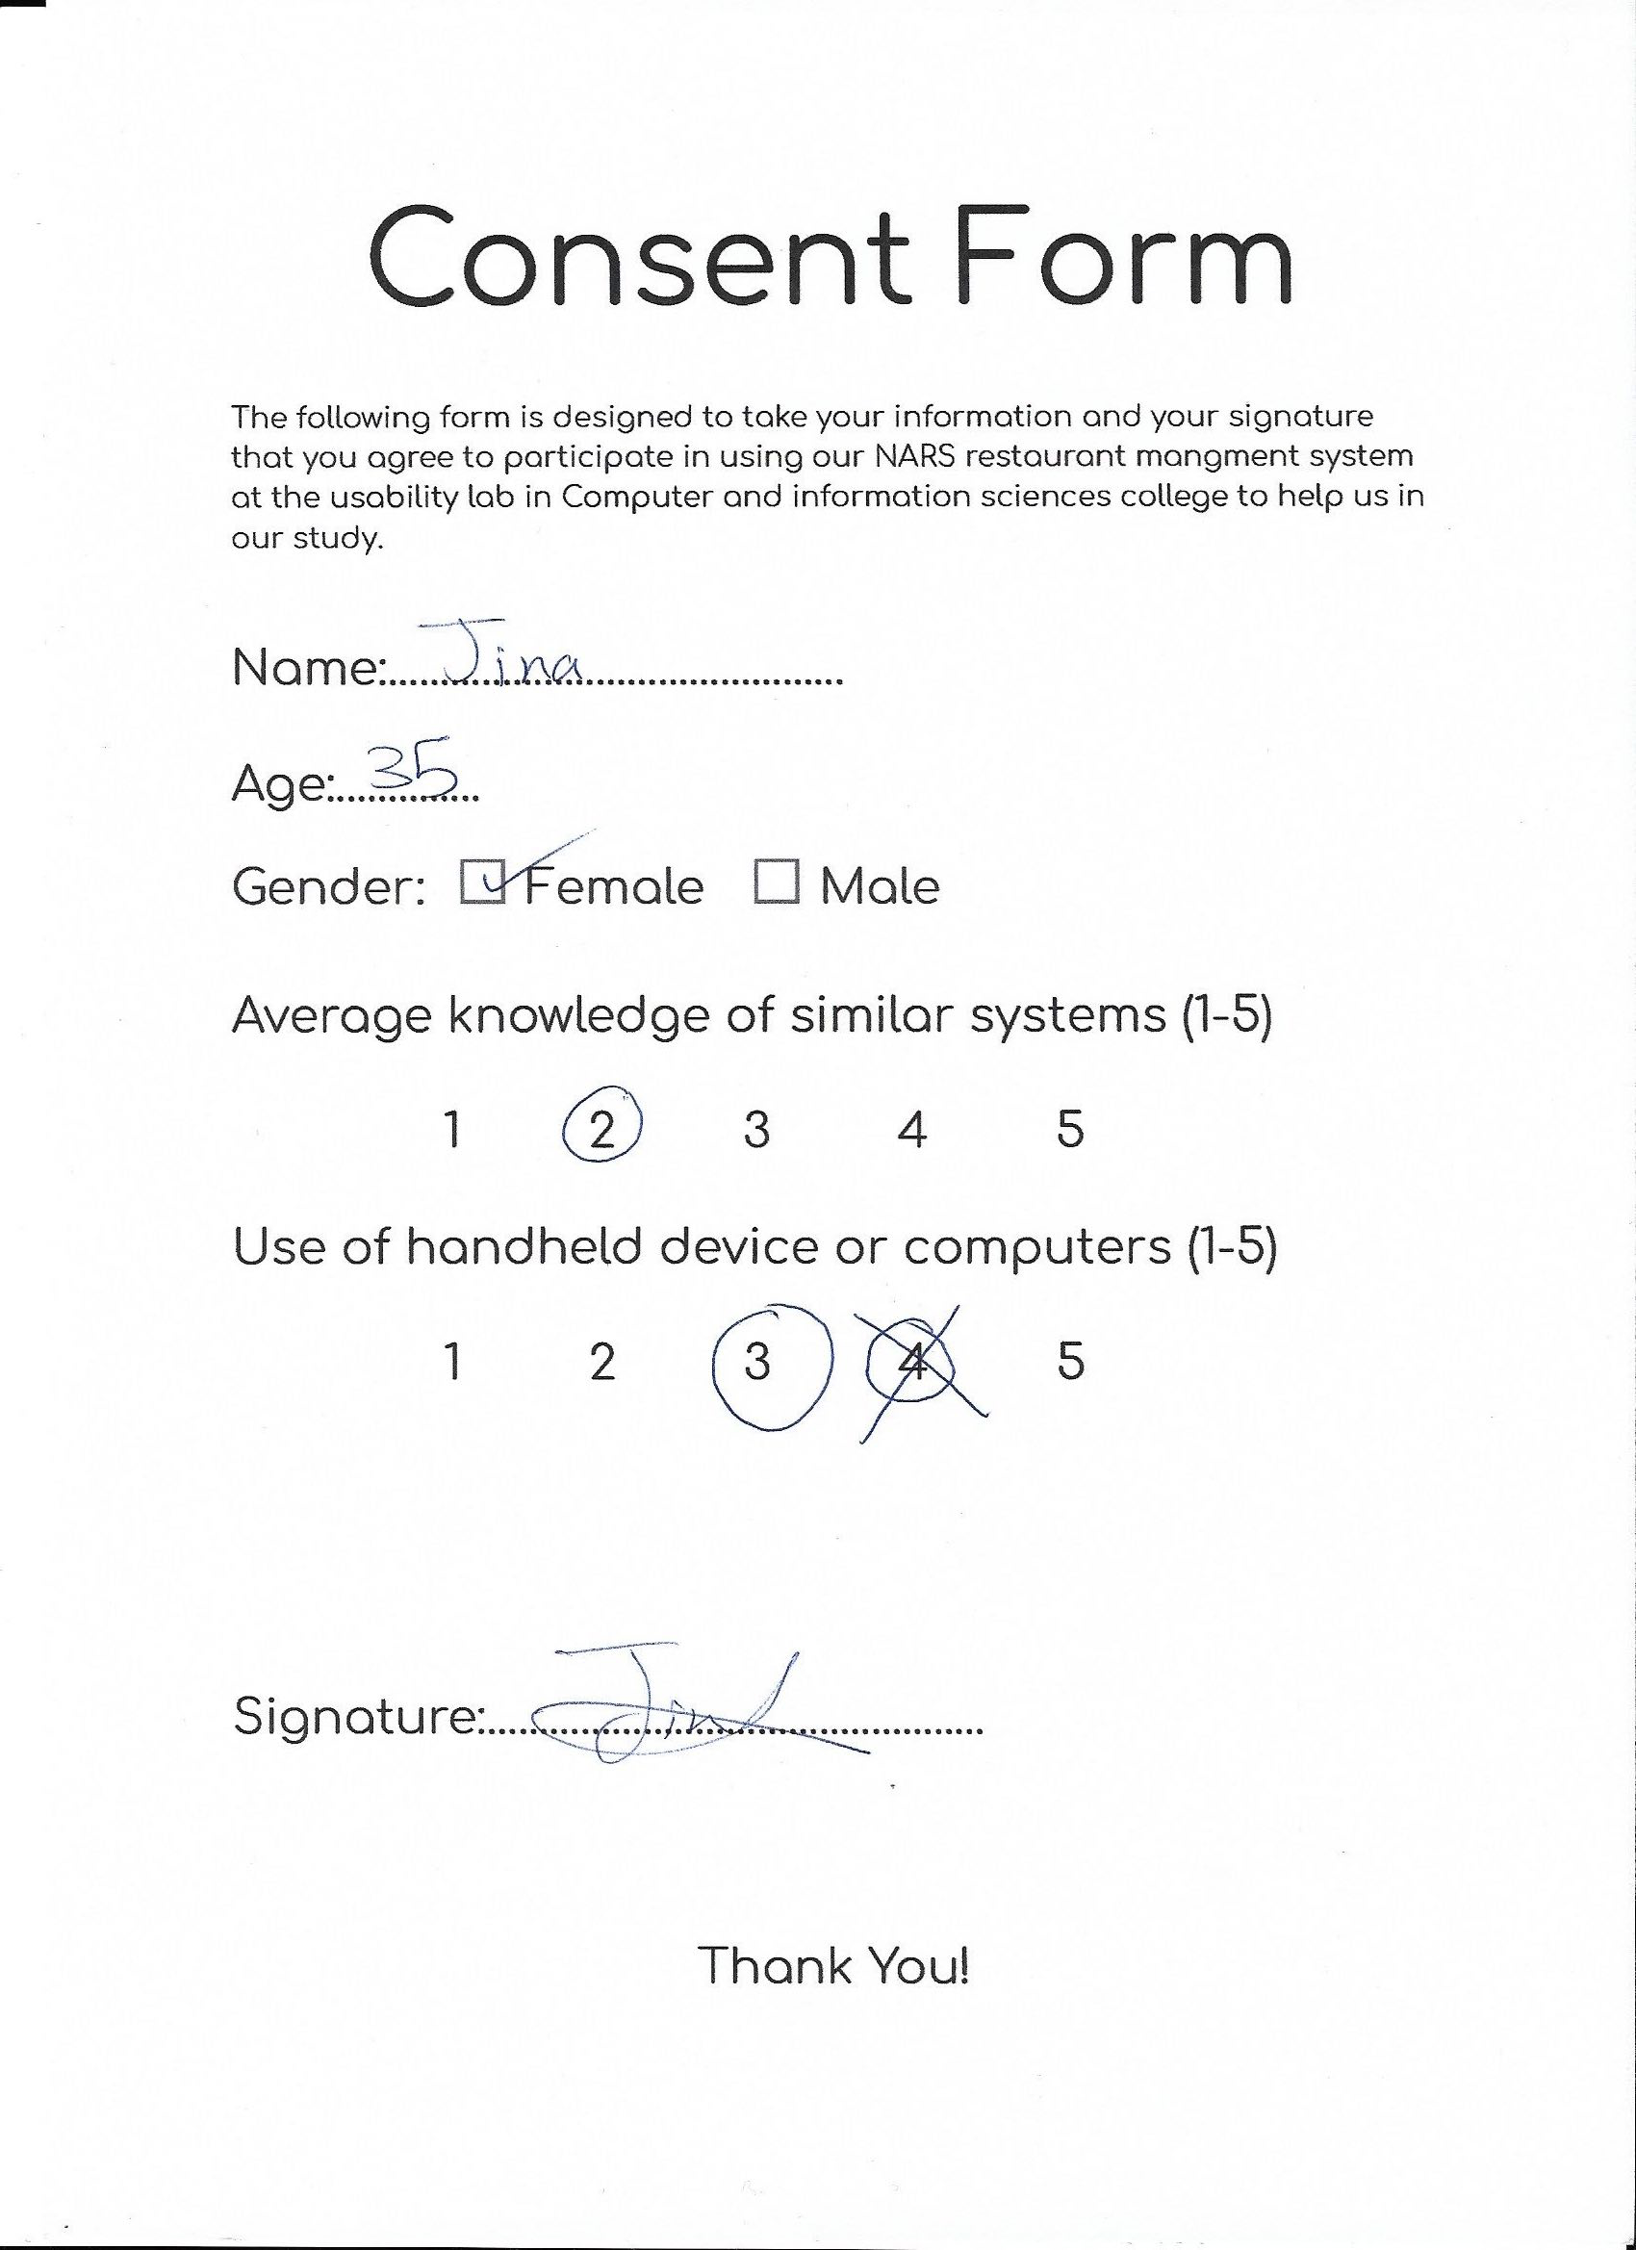

Participant 2:

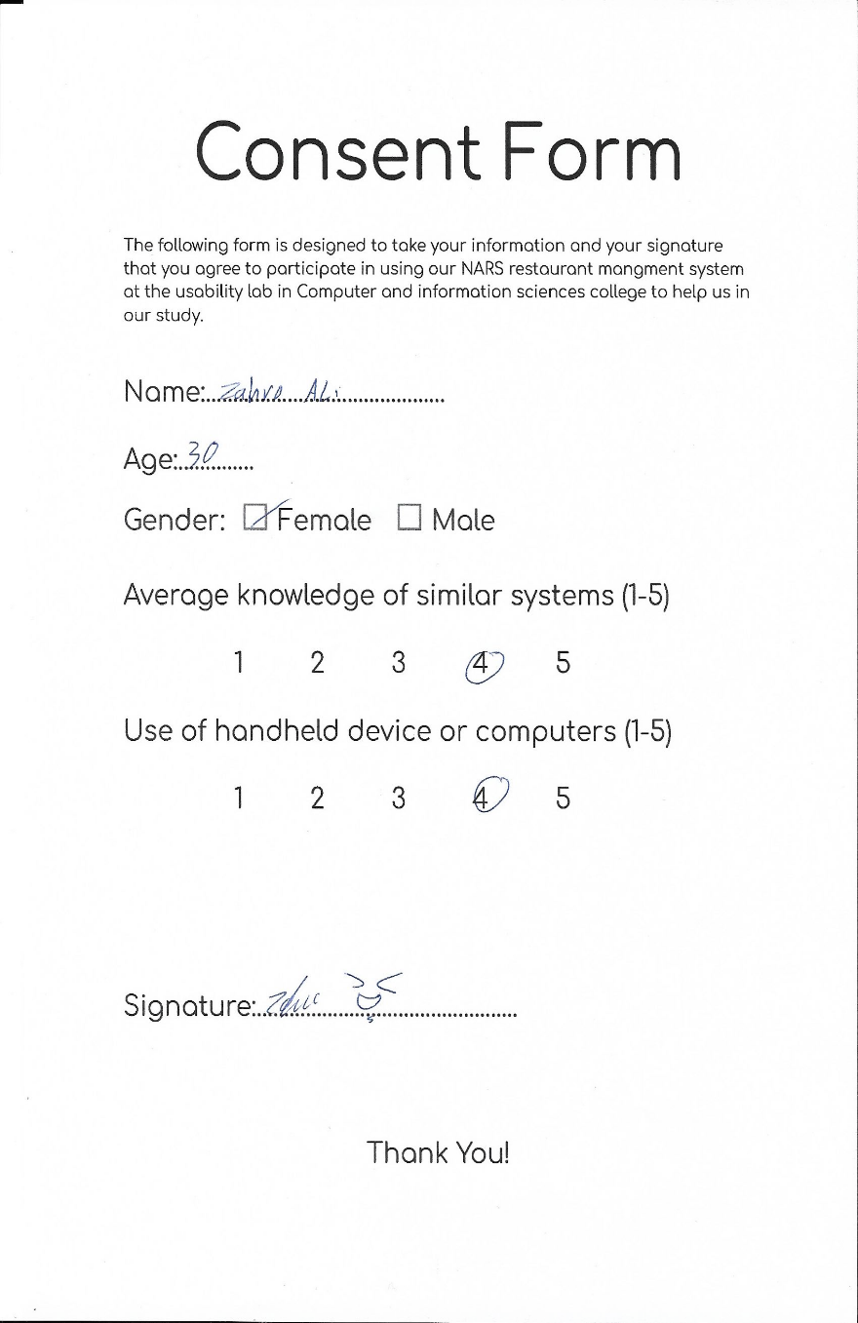

Participant 3:

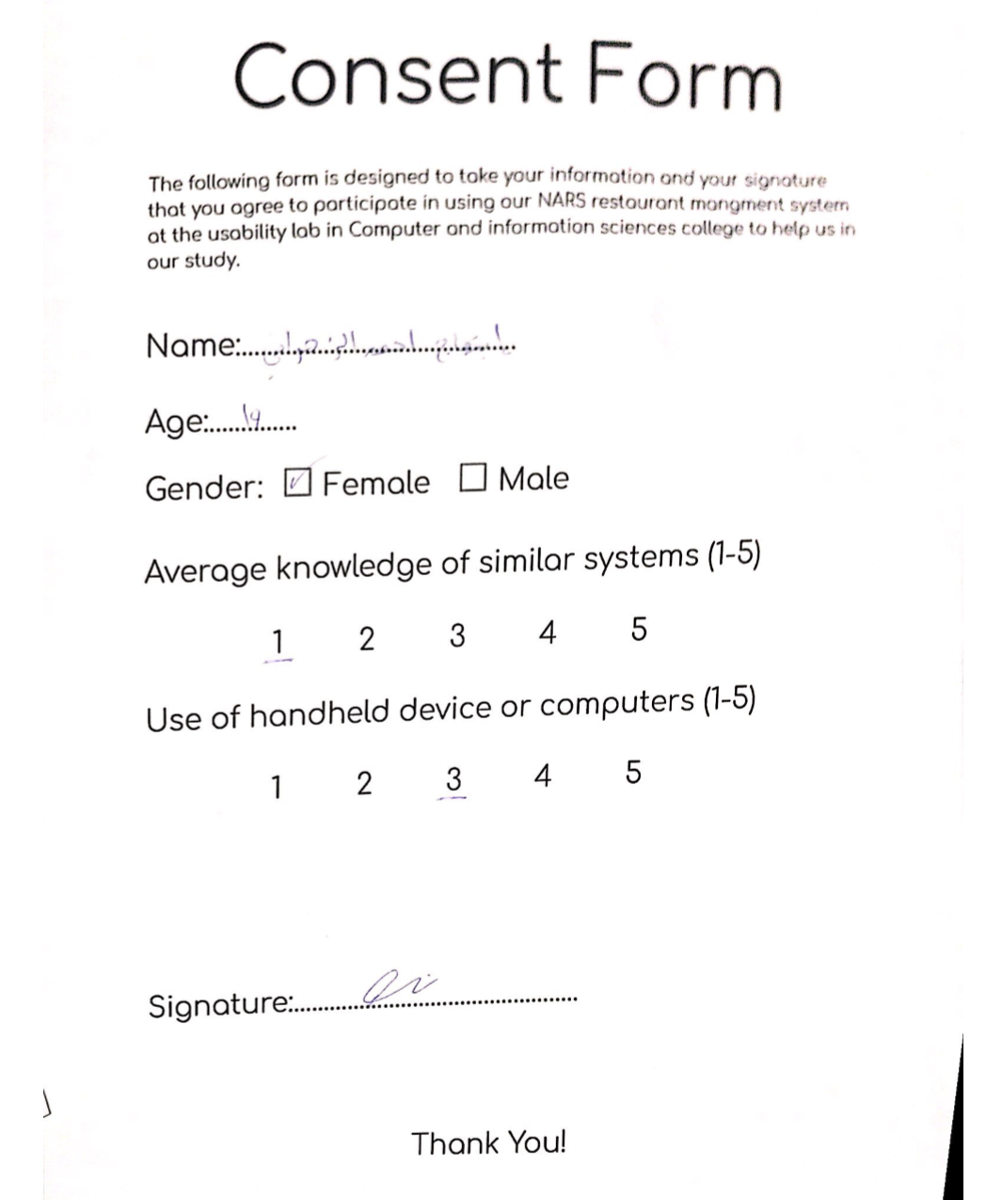

Participant 4:

